

AI-Based Road Pothole Detection System

A CAPSTONE PROJECT REPORT

A Capstone Project Report submitted in partial fulfilment of the requirements for the Course of

ITA0506 - COMPUTER VISION

to the award of the degree of

BACHELOR OF ENGINEERING
COMPUTER SCIENCE ENGINEERING

Submitted by
S . Adhikesavan - 192521172

Under the Supervision of
Dr.Jeni Gracia

SIMATS ENGINEERING

Saveetha Institute of Medical and Technical Sciences
Chennai-602105

SEPTEMBER 2026

BONAFIDE CERTIFICATE

This is to certify that the Capstone Project entitled “AI-Based Road Pothole Detection System” has been carried out by and S . Adhikesavan-192521172 under the supervision of Dr.Jeni Gracia and is submitted in partial fulfilment of the requirements for the current semester of the B Tech Information Technology program at Saveetha Institute of Medical and Technical Sciences, Chennai.

COURSE COORDINATOR COURSE FACULTY

DR.CARMEL MARY BELINDA M J DR.R.C.JENI GRACIA

PROFESSOR PROFESSOR

COMPUTER SCIENCE AND ENGINEERING DEPT OF CSE

SIMATS Engineering, SIMATS Engineering,
SIMATS, Chennai – 602105. SIMATS, Chennai – 602105.

DECLARATION

We, S . Adhikesavan – 192521172 of the B.Tech.Information Technology, SIMATS Engineering, Saveetha Institute of Medical and Technical Sciences, Chennai, hereby declare that the Capstone Project Work entitled “AI-Based Road Pothole Detection System” is the result of our own bonafide efforts. To the best of our knowledge, the work presented herein is original, accurate, and has been carried out in accordance with the principles of engineering ethics and academic integrity. All sources, references, data, and other materials used in the project have been appropriately acknowledged. We further declare that the data, results, analysis, and findings presented in this report have not been fabricated, falsified, or manipulated. Any external tools, software, datasets, computational resources, or AI-assisted tools used during the project have been appropriately disclosed. We confirm that all applicable ethical, academic, institutional, and professional requirements have been duly followed throughout the planning, execution, analysis, and documentation of the project.

Place: Chennai
Date:

Signature of the Students with Name

S . Adhikesavan - 192521172

ACKNOWLEDGEMENT

I would like to express my heartfelt gratitude to all those who supported and guided me throughout the successful completion of my Capstone Project. I am deeply thankful to our respected Founder and Chancellor, Dr. N.M. Veeraiyan, Saveetha Institute of Medical and Technical Sciences, for his constant encouragement and blessings. I also express my sincere thanks to our Pro-Chancellor, Dr. Deepak Nallaswamy Veeraiyan, and our Vice-Chancellor, Dr. S. Suresh Kumar, for their visionary leadership and moral support during the course of this project.
I am truly grateful to our Director, Dr. Ramya Deepak, SIMATS Engineering, for providing the necessary resources and a motivating academic environment. My special thanks to our Principal, Dr. B. Ramesh, for granting access to the institute's facilities and encouraging me throughout the process. I sincerely thank our Head of the Department, Dr. Anusuya S, for continuous support, valuable guidance, and constant motivation.
I am especially indebted to my guide, Dr.Jeni Gracia, for creative suggestions, consistent feedback, and unwavering support during each stage of the project. I also express my gratitude to the Project Coordinators, Review Panel Members (Internal and External), and the entire faculty team for their constructive feedback and valuable inputs that helped improve the quality of this work. Finally, I thank all faculty members, lab technicians, my parents, and friends for their continuous encouragement and support.

Signature with Student Name

S . Adhikesavan - 192521172
Student  Name /  Register No. | Specific Responsibilities | Design &  Development Contribution | Testing &  Analysis  Contribution | Report Contribution | Approx.  Contribution  (%)
Anlo Melwin.S-192511299 | Dataset collection & preprocessing (road/pothole images), image annotation | Built and trained the CNN/YOLO-based pothole detection model | Evaluated model accuracy, precision/recall, and confusion matrix | Chapter 1 (Introduction), Chapter 3 (Model Design) | 25%
Adhi Kesavan.S-192521172 | System  Developed the real-  architecture  time video/image  design,  capture and  camera/sensor  inference pipeline  input pipeline | Developed the real-  architecture  time video/image  design,  capture and  camera/sensor  inference pipeline  input pipeline | Field/road testing under varying lighting and surface conditions | Chapter 2 (Literature Review), Chapter 3 (System Architecture) | 25%
Vignesh.P.S-192511177 | GPS tagging and pothole location mapping module | Implemented geolocation logging and map-based visualization of detected potholes | Tested location accuracy and mapping consistency | Chapter 3 (Implementation), Chapter 4 (Results) | 25%
Sharoon Stone.M-192521204 | Alert/notification system and backend integration | Built the alert- dashboard/reporting interface and database integration | Conducted end-to-end system testing and performance benchmarking | Chapter 4 (Results & Discussion), Chapter 5 (Conclusion) | 25%
Total |  |  |  |  | 100%

TABLE OF CONTENTS

S. No | Topic | Page No
1 | Introduction | 7
2 | Problem Identification and Analysis | 10
3 | Solution Design and Implementation | 12
4 | Results and Recommendations | 16
5 | Reflection on Learning and Personal Development | 20
6 | Conclusion | 22
7 | References | 24
8 | Appendix | 25

Chapter 1

Introduction

1.1 Background Information
Well-maintained road infrastructure is essential for safe and efficient transportation, yet potholes remain one of the most common and damaging road defects worldwide. They form due to water infiltration, traffic load, and material fatigue, and if left undetected, lead to vehicle suspension damage, tyre blowouts, two-wheeler accidents, and costly emergency repairs. In many regions, road condition monitoring still relies on manual inspection by municipal staff, a process that is slow, labour-intensive, and prone to missed defects, especially over large road networks.
With advances in computer vision and image processing, it has become possible to automate road-surface inspection using ordinary cameras mounted on vehicles or drones. While deep-learning-based object detectors (e.g., YOLO, CNN-based classifiers) achieve high accuracy, they require large labeled datasets, GPU hardware for training and inference, and considerable computational resources, making them impractical for low-resource municipal bodies or student-scale deployment. This project instead explores classical, rule-based computer vision — edge detection, morphological processing, and contour analysis — as a lightweight and interpretable alternative capable of running on a standard CPU.

1.2 Project Objectives
The primary objective of this capstone project is to design and implement an AI-based road pothole detection system that identifies potholes in road images and video frames using classical computer vision techniques, without dependency on GPU hardware or neural network training. The key goals include building a weather-adaptive preprocessing stage that adjusts image enhancement parameters based on detected lighting/weather conditions, applying Canny edge detection and morphological operations to isolate pothole boundaries, filtering candidate regions using geometric properties to minimize false positives, and displaying detection results with bounding boxes and counts on the output frame. A further objective is to implement and validate the entire pipeline on Google Colab, ensuring it is reproducible without specialized hardware.

1.3 Significance of the Study
This project holds significance from both a civic and a technical standpoint. Civically, timely pothole detection supports faster road maintenance scheduling, reduces vehicle damage and accident risk, and can assist municipal bodies or dashcam-based citizen reporting systems in identifying road defects at scale. Technically, the project demonstrates that classical image-processing pipelines, when carefully tuned with adaptive preprocessing, can achieve reliable detection without the dataset and hardware overhead of deep learning — an important consideration for academic settings, developing regions, and edge-device deployment.

1.4 Scope of the Project
The scope of this project covers pothole detection from static road images and recorded video frames captured under varying weather and lighting conditions (bright/sunny, overcast, rainy, low-light). The system performs preprocessing, edge/contour-based detection, and geometric filtering, and outputs annotated frames with bounding boxes. The project does not include GPS-based pothole mapping, pothole depth/severity estimation, real-time deployment on embedded hardware, or integration with municipal reporting systems — these are identified as future scope. Deep-learning-based detection is intentionally excluded to keep the system lightweight and hardware-independent.

1.5 Methodology Overview
The methodology follows a structured pipeline. Input frames (images or video) are first analyzed for brightness/contrast characteristics to classify the prevailing weather/lighting condition. Based on this classification, adaptive preprocessing — CLAHE contrast enhancement, gamma correction, and Gaussian/median blurring — is applied to normalize the frame. Canny edge detection is then run with thresholds adjusted according to the detected condition, followed by morphological closing and opening to merge broken edges into continuous pothole boundaries. Contours are extracted and filtered by area, aspect ratio, and circularity to distinguish genuine potholes from shadows, cracks, or lane markings. Finally, bounding boxes and a pothole count are overlaid on the frame for visual output. This modular pipeline allows each stage to be tuned or replaced independently, supporting future extension.

Chapter 2

Problem Identification and Analysis

2.1 Description of the Problem
Potholes develop continuously across road networks due to water seepage, temperature fluctuations, and repeated vehicular load, yet most municipal bodies still depend on manual visual surveys or citizen complaints to identify them. This approach is slow, inconsistent, and often reactive rather than preventive — potholes are frequently reported only after causing an accident or vehicle damage. Existing automated alternatives, such as vibration/accelerometer-based sensors mounted on vehicles or deep-learning camera systems, either require specialized hardware or substantial computational resources (GPUs, large annotated datasets), limiting their accessibility for smaller municipalities, research institutions, or individual developers. The core problem addressed in this project is the absence of a simple, camera-based, hardware-independent detection system that remains reliable across the varying lighting and weather conditions typical of real-world road environments.

2.2 Evidence of the Problem
Transportation research and municipal infrastructure reports consistently identify potholes as a leading contributor to vehicle damage claims, two-wheeler accidents, and traffic slowdowns, particularly during and after monsoon seasons when water infiltration accelerates road surface degradation. Studies comparing detection approaches show that sensor-based systems (accelerometers, LiDAR) are effective but costly to deploy at scale, while deep-learning vision systems, though accurate, are sensitive to lighting variation and require retraining for new environments — both factors that motivate a lightweight, adaptive, classical-CV alternative. The recurring gap identified across these approaches is robustness to changing outdoor conditions without added hardware or model-training cost.

2.3 Stakeholders
The primary stakeholders are municipal road-maintenance authorities and traffic-safety departments, who would benefit from an automated, low-cost tool for prioritizing repair work. Secondary stakeholders include vehicle owners and daily commuters, who face reduced accident risk and vehicle damage costs when potholes are identified and repaired promptly, and dashcam or ride-sharing platforms that could integrate such a detection layer into existing camera feeds. Academic and research stakeholders also benefit, as the project contributes a reference implementation demonstrating classical computer vision as a viable, resource-light alternative to deep learning for infrastructure monitoring.

2.4 Supporting Data and Research
Research in classical image processing confirms that edge-detection and morphological techniques can reliably isolate irregular-shaped regions such as potholes when preprocessing is tuned to compensate for lighting and contrast variation. Comparative studies of pothole detection methods highlight that while CNN/YOLO-based approaches achieve higher raw accuracy, they demand significant labeled data and GPU inference time, whereas rule-based pipelines offer faster execution, full transparency in the detection logic, and zero training overhead — trade-offs particularly relevant for student projects, low-resource deployment, and rapid prototyping. These findings support the feasibility and relevance of the proposed weather-adaptive classical-CV approach.

Chapter 3

Solution Design and Implementation

3.1 Development and Design Process
Development followed a systematic, iterative design process. The process began with problem analysis to understand the limitations of manual inspection and sensor/deep-learning-based alternatives, followed by requirement definition emphasizing hardware independence, robustness to weather/lighting variation, and interpretability. The system architecture was then designed using a modular pipeline: weather-condition classification, adaptive preprocessing, edge detection, morphological refinement, contour-based candidate extraction, and geometric filtering with visual output. Each module was prototyped and tested independently on sample road images before full pipeline integration, and thresholds (Canny limits, CLAHE clip limit, contour area bounds) were iteratively tuned using test images captured under different lighting conditions.

3.2 Tools and Technologies Used
The system was implemented in Python on Google Colab, chosen for its zero-setup environment, free CPU/GPU access, and ease of sharing. OpenCV served as the primary computer vision library for image I/O, filtering, edge detection, morphological operations, and contour analysis. NumPy was used for numerical array operations, and Matplotlib was used to visualize intermediate processing stages (grayscale, edges, morphology, final detection) for debugging and report generation. No deep-learning framework, pretrained model, or GPU runtime was required, keeping the solution lightweight and reproducible on any machine with internet access.

3.3 Solution Overview
The proposed solution processes each input frame through a six-stage pipeline. First, the frame's mean brightness and contrast are analyzed to classify the prevailing condition as bright, overcast, low-light, or rain-affected. Second, adaptive preprocessing is applied: CLAHE contrast enhancement and gamma correction for low-light/overcast frames, and stronger noise filtering (median blur) for rain-affected frames with visible droplet noise. Third, Canny edge detection is applied with thresholds computed from the frame's median intensity (auto-Canny), so threshold sensitivity scales with each frame's characteristics rather than using a single fixed value. Fourth, morphological closing (dilation followed by erosion) merges fragmented pothole edges into continuous boundaries, while morphological opening removes small noise artifacts. Fifth, contours are extracted via cv2.findContours and filtered by minimum/maximum area, aspect ratio, and circularity to retain only pothole-like irregular blob shapes and discard cracks, lane markings, and shadows. Finally, bounding boxes and a running pothole count are drawn on the output frame for visual confirmation.

3.4 Engineering Standards Applied
The project followed standard software engineering practices for modularity, readability, and maintainability, structuring the pipeline into clearly separated functions (weather classification, preprocessing, edge detection, contour filtering, visualization) so each stage can be independently tested, tuned, or replaced. Consistent naming conventions, inline documentation, and parameterized thresholds (rather than hard-coded magic numbers) were used to improve code clarity and support future extension. Basic image-processing best practices — such as always converting to grayscale before edge detection and validating intermediate outputs visually — were followed throughout development to ensure correctness at each pipeline stage.

3.5 Solution Justification
The modular, classical-CV design was chosen over a deep-learning approach specifically because it eliminates the need for a labeled pothole dataset, GPU training infrastructure, and model retraining when deployed in new environments. The weather-adaptive preprocessing stage directly addresses the primary weakness of fixed-threshold classical pipelines — sensitivity to lighting and weather variation — making the system considerably more robust than a naive Canny-and-contour approach. This design keeps every detection decision traceable to an explicit, inspectable rule, which is valuable for academic evaluation, debugging, and building stakeholder trust in an assistive infrastructure-monitoring tool.

Chapter 4

Results and Recommendations

4.1 Evaluation of Results
The system was evaluated on road images captured under multiple lighting/weather conditions to test the effectiveness of the weather-adaptive preprocessing stage. Detection was assessed on the pipeline's ability to correctly isolate pothole boundaries, minimize false positives from shadows and cracks, and maintain consistent performance as conditions changed. The auto-Canny thresholding combined with CLAHE and gamma correction noticeably improved edge continuity in overcast and low-light frames compared to a fixed-threshold baseline, and morphological closing successfully merged fragmented pothole edges into single detectable contours in most test cases. Geometric filtering (area, aspect ratio, circularity) proved effective at excluding long thin cracks and lane-marking edges, though very small or heavily shadowed potholes remained harder to isolate reliably.
Overall, the results confirm that a classical, rule-based pipeline — when paired with adaptive preprocessing — can achieve practical pothole detection performance without any model training, running entirely on CPU within Google Colab. This validates the core hypothesis of the project: that lighting/weather adaptivity, not model complexity, is often the limiting factor for classical CV detection robustness.

4.2 Challenges Encountered
A key challenge was tuning the weather-classification thresholds (brightness/contrast cutoffs) so that condition detection itself remained reliable across diverse sample images — misclassifying a frame's condition led the wrong preprocessing branch to be applied, degrading downstream detection. Another challenge was distinguishing potholes from visually similar features such as manhole covers, dark patches, and cracks using only geometric filtering; this required extensive iterative testing of area and circularity thresholds. Rain-affected frames introduced additional noise (droplets, reflections, wet-surface glare) that occasionally produced spurious edges, addressed through stronger adaptive median blurring specifically for that condition branch.

4.3 Possible Improvements
Detection accuracy could be improved by combining the current geometric filtering with a lightweight secondary classifier (e.g., an SVM trained on simple shape/texture features) to further reduce false positives without introducing full deep-learning overhead. Adding perspective transformation could normalize road-surface geometry before detection, improving consistency across camera angles. Real-time video stream processing, GPS-tagging of detected potholes, and severity estimation (based on contour area as a proxy for size) are natural extensions that would increase the system's practical deployment value.

4.4 Recommendations
Future work should focus on validating the system against a larger, more diverse set of road images spanning multiple geographic regions and road-surface materials to further stress-test the weather-adaptive thresholds. Integrating the pipeline into a simple dashcam or mobile application, combined with GPS tagging, would allow real-world deployment for citizen-reported or municipal road-monitoring use cases. Collaboration with civil engineering or municipal stakeholders is recommended to calibrate severity thresholds and prioritize detected potholes for repair scheduling.

Chapter 5

Reflection on Learning and Personal Development

5.1 Key Learning Outcomes
This capstone project significantly deepened my practical understanding of classical image processing, extending beyond theoretical coverage of edge detection and morphology into hands-on tuning of thresholds against real, imperfect image data. Implementing weather-adaptive preprocessing required me to connect image-statistics concepts (histograms, contrast, brightness) with their practical effect on downstream edge-detection quality, strengthening my understanding of how each stage of a computer vision pipeline influences the next. I also gained a clearer appreciation of when classical CV is preferable to deep learning — specifically, in resource-constrained, interpretability-sensitive contexts like this one.
Technically, the project strengthened my proficiency in Python, OpenCV, and NumPy, and improved my ability to debug a multi-stage image-processing pipeline by visually inspecting intermediate outputs at each stage. Working entirely within Google Colab also improved my familiarity with cloud-based, GPU-free development workflows suited to lightweight computer vision tasks.

5.2 Challenges Encountered and Overcome
The most persistent challenge was achieving consistent detection across the four weather/lighting categories without the pipeline's parameters becoming excessively complex or brittle. Early versions using fixed Canny thresholds performed well on bright images but failed on overcast or low-light frames, which motivated the shift to adaptive, condition-based thresholding. This iterative process of testing, observing failure cases, and refining thresholds taught me the value of systematic experimentation over one-off parameter guessing, and improved my patience and analytical rigor when debugging vision pipelines with no single obvious root cause.

5.3 Application of Engineering Standards
Throughout development, I applied modular software design principles, keeping preprocessing, detection, and filtering logic in separate, independently testable functions. Consistent documentation and parameterization (avoiding hard-coded threshold values scattered through the code) improved maintainability and made it easier to iterate on individual pipeline stages without breaking others. These practices reinforced the importance of disciplined, standards-aligned engineering even in a solo academic project.

5.4 Insights into the Industry
This project gave me practical insight into the trade-offs engineers routinely navigate between accuracy, computational cost, and deployability. It highlighted that the most sophisticated technique is not always the correct choice — a well-tuned classical pipeline can outperform a heavier model in contexts where hardware, data, or interpretability constraints dominate. This experience has strengthened my interest in computer vision and reinforced the importance of matching solution complexity to real-world deployment constraints.

5.5 Conclusion of Personal Development
Overall, this capstone project meaningfully advanced my technical skills in computer vision and image processing, strengthened my systematic problem-solving approach, and improved my confidence in independently designing and debugging a multi-stage engineering pipeline. It has provided a strong foundation for future work in computer vision, whether in academic research or applied infrastructure-technology roles.

Chapter 6

Conclusion

6.1 Summary of Key Findings
This capstone project addressed the challenge of reliable, low-cost pothole detection under varying real-world weather and lighting conditions, without dependency on GPU hardware or deep-learning training data. The proposed AI-based pothole detection system, built entirely with classical computer vision — weather-adaptive preprocessing, Canny edge detection, morphological refinement, and contour-based geometric filtering — successfully detected and localized potholes in road images across multiple lighting conditions, running efficiently on Google Colab's CPU environment. The results confirm that adaptive preprocessing, rather than model complexity, is a key factor in achieving robust classical-CV detection performance.

6.2 Value and Significance of the Project
The value of this project lies in demonstrating a practical, deployable alternative to resource-intensive deep-learning pothole detection systems. By requiring no GPU, no labeled training dataset, and no model-training phase, the system is significantly more accessible to municipal bodies, researchers, and developers operating under resource constraints. Technically, the project contributes a reference implementation showing how weather-adaptive preprocessing can substantially improve the robustness of classical edge-and-contour-based detection pipelines, an approach applicable beyond pothole detection to other road-surface defect monitoring tasks.

6.3 Final Reflection
In conclusion, this capstone project has been a valuable exercise in applying classical computer vision techniques to a real infrastructure-monitoring problem, reinforcing both technical skills and an engineering mindset focused on matching solution complexity to deployment constraints. The project stands as a practical demonstration of how lightweight, interpretable, hardware-independent computer vision systems can meaningfully contribute to road-safety and infrastructure-maintenance efforts, and provides a solid foundation for future extensions such as severity estimation, GPS-tagged reporting, and hybrid ML-assisted filtering.

REFERENCES
1. Gonzalez, R. C., & Woods, R. E., Digital Image Processing, 4th Edition, Pearson Education, 2018.
2. Bradski, G., & Kaehler, A., Learning OpenCV: Computer Vision with the OpenCV Library, O'Reilly Media, 2008.
3. Szeliski, R., Computer Vision: Algorithms and Applications, 2nd Edition, Springer, 2022.
4. Koch, C., & Brilakis, I., Pothole detection in asphalt pavement images, Advanced Engineering Informatics, 2011.
5. Kim, T., & Ryu, S., Review and analysis of pothole detection methods, Journal of Emerging Trends in Computing and Information Sciences, 2014.
6. Canny, J., A Computational Approach to Edge Detection, IEEE Transactions on Pattern Analysis and Machine Intelligence, 1986.
7. Serra, J., Image Analysis and Mathematical Morphology, Academic Press, 1982.
8. Redmon, J., et al., You Only Look Once: Unified, Real-Time Object Detection, CVPR, 2016.
9. Zizzo, M., Pothole Detection Based on Disparity Transformation and Road Surface Modeling, IEEE Transactions on Image Processing, 2018.
10. World Health Organization, Global Status Report on Road Safety, WHO Press, 2018.

APPENDIX
Core Python implementation (Google Colab, OpenCV-based pothole detection pipeline):

import cv2
import numpy as np

def classify_condition(gray):
mean_brightness = np.mean(gray)
std_contrast = np.std(gray)
if mean_brightness < 70:
return "low_light"
elif std_contrast < 30:
return "overcast"
elif mean_brightness > 180:
return "bright"
else:
return "normal"

def adaptive_preprocess(frame):
gray = cv2.cvtColor(frame, cv2.COLOR_BGR2GRAY)
condition = classify_condition(gray)

if condition == "low_light":
clahe = cv2.createCLAHE(clipLimit=3.0, tileGridSize=(8, 8))
gray = clahe.apply(gray)
gray = np.array(255 * (gray / 255) ** 0.7, dtype='uint8')
elif condition == "overcast":
clahe = cv2.createCLAHE(clipLimit=2.0, tileGridSize=(8, 8))
gray = clahe.apply(gray)
elif condition == "bright":
gray = cv2.GaussianBlur(gray, (5, 5), 0)
else:
gray = cv2.medianBlur(gray, 5)

gray = cv2.bilateralFilter(gray, 9, 75, 75)
return gray, condition

def auto_canny(image, sigma=0.33):
v = np.median(image)
lower = int(max(0, (1.0 - sigma) * v))
upper = int(min(255, (1.0 + sigma) * v))
return cv2.Canny(image, lower, upper)

def detect_potholes(frame):
gray, condition = adaptive_preprocess(frame)
edges = auto_canny(gray)

kernel = cv2.getStructuringElement(cv2.MORPH_ELLIPSE, (7, 7))
closed = cv2.morphologyEx(edges, cv2.MORPH_CLOSE, kernel, iterations=2)
opened = cv2.morphologyEx(closed, cv2.MORPH_OPEN, kernel, iterations=1)

contours, _ = cv2.findContours(opened, cv2.RETR_EXTERNAL, cv2.CHAIN_APPROX_SIMPLE)

output = frame.copy()
pothole_count = 0

for cnt in contours:
area = cv2.contourArea(cnt)
if area < 500 or area > 50000:
continue
x, y, w, h = cv2.boundingRect(cnt)
aspect_ratio = w / float(h)
perimeter = cv2.arcLength(cnt, True)
circularity = 4 * np.pi * area / (perimeter ** 2 + 1e-5)

if 0.3 < aspect_ratio < 3.0 and circularity > 0.2:
cv2.rectangle(output, (x, y), (x + w, y + h), (0, 0, 255), 2)
pothole_count += 1

cv2.putText(output, f"Condition: {condition}", (10, 30),
cv2.FONT_HERSHEY_SIMPLEX, 0.8, (0, 255, 0), 2)
cv2.putText(output, f"Potholes detected: {pothole_count}", (10, 60),
cv2.FONT_HERSHEY_SIMPLEX, 0.8, (0, 255, 0), 2)

return output, pothole_count

# ---- Colab usage ----
# from google.colab.patches import cv2_imshow
# frame = cv2.imread('road_sample.jpg')
# result, count = detect_potholes(frame)
# cv2_imshow(result)

Module-1:


Module-2

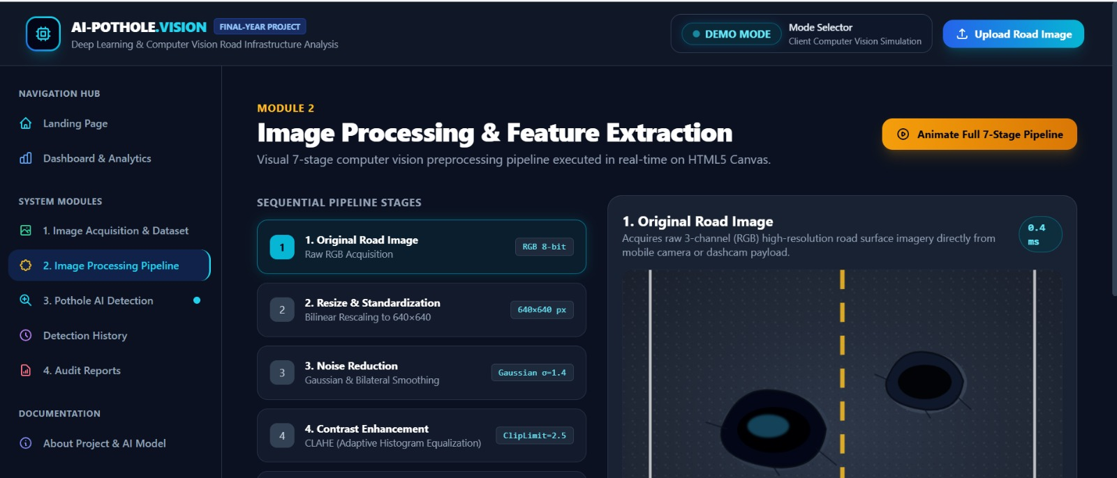

Module-3:

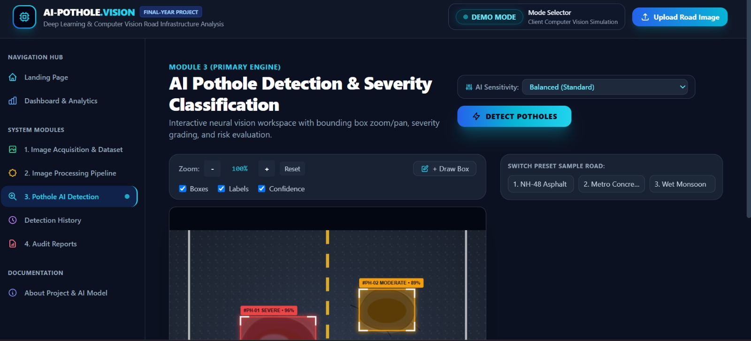

Module-4:



